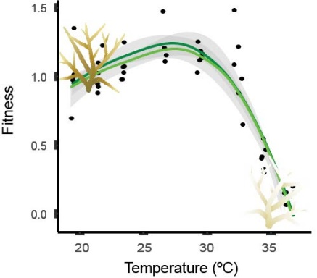
Katelyn Gould Gould054@live.unc.edu
PhD Candidate in Biology, UNC Chapel Hill, NC Carrboro, NC
Coral Ecophysiology and Restoration (303) 406-8799

B.S. in Biology and Environmental Sciences
Regis University, Denver, CO

Research Focus: I study reef-building corals in the Caribbean to understand how temperature determines fitness and responses to climate change. I integrate physiological, ecological, and novel restoration techniques to identify environments and circumstances that lead to increased survival. I aim to publicize my results across the field and within a conservation context around the globe.

CERTIFICATIONS FIELD SKILLS LAB SKILLS ADMINISTRATIVE
PADI Master diver Long-term ecological monitoring Coral and fish husbandry Data entry and quality control
CPR, AED, & First Aid Deck hand & boat experience Mesocosm & Aquarist design R statistics and data analyses
Nitrox and Rescue diver AAUS scientific diver Laboratory management SOP & certification auditing

RESEARCH EXPERIENCE:
Coral Restoration: Genotype by Environment Interactions 2019-Present
Florida Keys, FL Principle investigator
- Monitored transplanted Orbicella annularis in a two-year restoration project
- Assessed seasonal fitness across 4 transplantation sites
- Linked coral variation to local environmental differentiation

Thermal Sensitivities Across Depth 2018
Bermuda Institute of Ocean Sciences (BIOS), Bermuda Principle investigator
- Created thermal performance curves in 4 species of coral; Diploria labyrinthiformis, Orbicella franksi,
Montastrea cavernosa, and Porites astreoides
- Identified thermal thresholds and potential refuges from climate stress
Gould, K. J., Bruno, J. F., Ju, R., & Goodbody-Gringley, G. (2021). Upper-mesophotic and shallow reef corals exhibit similar thermal tolerance, sensitivity, and optima. Coral Reefs.

Novel Stress-reducing Techniques: Coral Restoration 2017
UNC-Chapel Hill, NC Principle investigator
- Tested aquaculture techniques to enhance coral fitness in Acropora cervicornis
- Quantified thermal performance under increasing thermal stress

Thermal Performance Assessment 2017
Bermuda Institute of Ocean Sciences (BIOS) Research Collaborator
- Measured fitness under thermal stress assay in Orbicella franksi
- Characterized localized thermal responses in Bermudian corals for comparative analyses
Silbiger, N. J., Goodbody-Gringley, G., Bruno, J. F., & Putnam, H. M. (2019). Comparative thermal performance of the reef-building coral Orbicella franksi at its latitudinal range limits. Marine Biology, 166(10), 1-14.

Investigating the Bahamian Pupfish Adaptive Radiation 2015
UNC-Chapel Hill, NC Principle investigator
- Performed mate preference trials across three species of Cyprinodon, snail-eater, scale-eater, and generalists
- Investigated developmental plasticity in phenotypic jaw structure in Cyprinodon under various feeding modes

WORK EXPERIENCE:
Biology Laboratory Instructor 2017-Present
University of North Carolina, Chapel Hill, NC
- Taught undergraduate courses in Biological Sciences (See TEACHING POSITIONS)
- Mentored 5 undergraduate students in laboratory research including physiological sampling and laboratory experiments

Quality Assurance Manager 2016-2018
Mettler Toledo formally Calibrate Inc., Chapel Hill, NC
- Worked closely with 35 field technicians to ensure quality system SOPs were implemented and documented
- Lead internal audits of calibration certifications , employee training, and company-wide accreditation and certifications
- Dictated upper-management meetings for Quality Control purposes and internal auditing
- Upheld documentation of training and personal information on all technicians during their employment

Lab Manager 2015-2017
University of North Carolina, Chapel Hill, NC
- Managed multiple ongoing research projects in the Martin Lab, including behavioral, genetic, and morphological studies
- Provided logistical planning, administrative coordination, and served as point of contact for lab
- Composed data tables via verbal dictation for multiple ongoing research projects
Martin, C. H., & Gould, K. J. (2020). Surprising spatiotemporal stability of a multi‐peak fitness landscape revealed by independent field experiments measuring hybrid fitness. Evolution letters, 4(6), 530-544.

Lab Technician 2014-2015
Lab Corp, Burlington, NC
- Coordinated inoculations and culturing of biologically hazardous samples for pathogen identification
- Maintained privacy data on patients’ medical results and typed personnel files

Fisheries Biological Observer 2014 The Bering Sea, Alaska
- Collected fisheries data and reported federal infractions including sensitive confidential data
to the National Marine Fisheries Service
- Data management and input for daily (14hr shifts) catches of up to 5 hulls of 50+ metric tons of catch and bycatch

Lead Field Technician 2013-2014 National Ecological Observatory Network, Boulder, CO
- Led operation teams in ecological monitoring
- Established and collected data for use in a national database

Biology Lab Manager 2012-2014
Regis University, Denver, CO
- Supervised 15 student employees in lab preparation for undergraduate and graduate level biology courses
- Maintained lab safety protocols and implemened time management skills for independent research
- Isolated and cultivated various microorganisms and invertebrate stocks for experimental manipulation and genetic crosses

TEACHING POSITIONS:
UNC-Chapel Hill, NC
- Biology 101 Laboratory 2020- Present
- Biology 101 Lecture 2019

BIOS, Bermuda Fall 2018
- Coral Reef Ecology
- Diving Research Methods
- Marine Biology and Oceanographic Research

UNC-IMS, Beaufort, NC
- AAUS Scientific Diving Summer 2018

UNC-Chapel Hill, NC
- Avian Biology Spring 2018
- Fundamentals of Human Anatomy Fall 2017

GRANTS AND AWARDS:
UNC-Chapel Hill, NC 2018- 2019
- AAUS Doctoral Scholarship
- BIOS Grant-In-Aid Award
- AAUS Doctoral Scholarship- Honorable Mention
- PADI Common Grant Foundation Grant

Regis University, Denver, CO 2010- 2013
- Research and Scholarship Council Grant
- Spark Grant

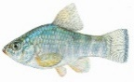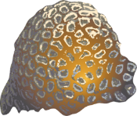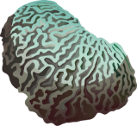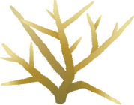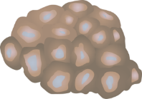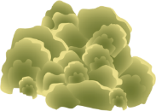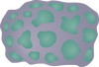
Cyprinodon Orbicella Diploria Acropora Montastrea Porites Orbicella
variegates franksi labyrinthiformis cervicornis cavernosa astreoides annularis

